Microsoft Teams is used widely at Birkbeck to deliver online teaching. With Teams you can attend live sessions, communicate with your class and arrange meetings with colleagues and teaching staff. This document contains important information that will help you understand how best to access Teams and get the full user experience.

To use the full functionality of Teams you should download the Teams app onto your computer or mobile device. You should also log in using your Birkbeck credentials:

- Username: username@student.bbk.ac.uk
- Password: your normal Birkbeck password you use for Moodle and My Birkbeck

Although you can attend online sessions in Teams without downloading the app and logging in with your Birkbeck credentials, you do so as a ‘guest’. Guest users do not have access to the full range of features within the sessions. Managing guests in a meeting can also cause complications for those running the sessions. We therefore strongly encourage you to use the app and your Birkbeck account.

Download Teams

- You can download the Teams app for both desktop and mobile, from the Download Microsoft Teams page.
- Alternatively, for mobile devices you can download the app from the App Store (iOS devices) or the Play Store (Android devices).
- For desktop devices you can also download the app from the Birkbeck Office 365 home page. Sign in with your Birkbeck credentials, click the Install Office button in the top right hand corner then select Office 365 apps. This will download Teams along with other Office apps including Word, Excel and Powerpoint.

Login to Teams using the desktop app
Open the app, enter your Birkbeck username, click Sign in then enter your password.

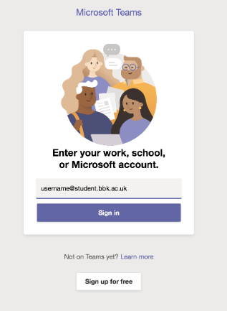
If you are using Teams on a Windows 10 computer you may also see this window. Uncheck the Allow my organisation to manage my device box then click the No, sign in to this app only link.

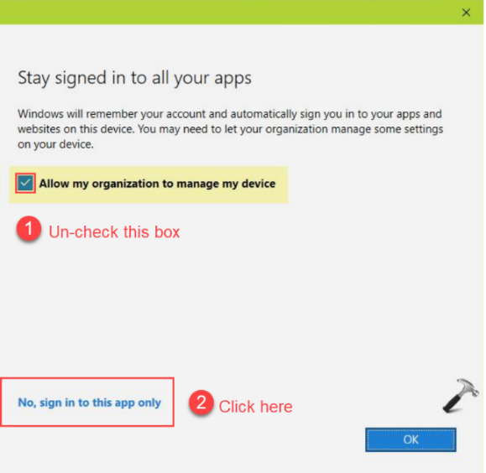
If you are already signed into Teams on another account (e.g for work), go to your profile picture in the top right corner and sign out of that account, then sign back in again using your Birkbeck credentials.

Breakout rooms: Your teaching staff may use breakout rooms in your sessions, to split you into smaller groups for focused discussions and brainstorming. If you are using the desktop app check the ‘new meeting experience’ is enabled. Click your profile picture in the top right corner, then select Settings. The Turn on new meeting experience box should be checked. If it is not, check it then restart Teams by signing out and back in again.

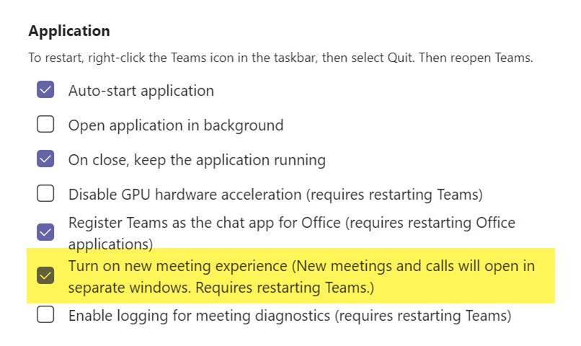

Login to Teams using the mobile app
Enter your Birkbeck username into the Teams Sign in screen, then your password.

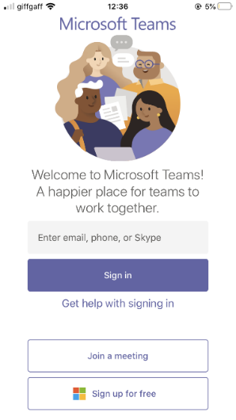

If you are already signed into Teams on another account (e.g. for work), you must add your Birkbeck account to your mobile device before you join your Birkbeck live sessions. To do this, click on the Menu icon on the top left corner of the app, and select Add Account.

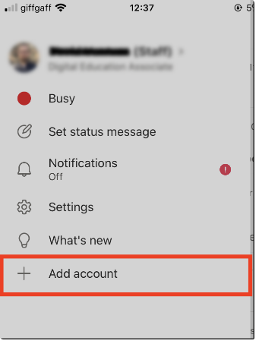

On the next screen, select the Sign in with another account option, and sign in with your Birkbeck credentials.

Once you have logged in with your Birkbeck credentials, you will be given the option to switch between accounts in the app Menu (under Accounts and Orgs). To ensure full functionality, make sure that you have your Birkbeck account selected before you join any live sessions at Birkbeck.

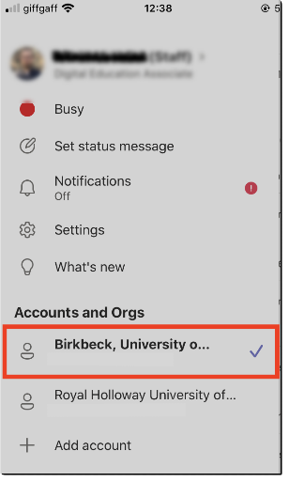
Breakout rooms: Your teaching staff may use breakout rooms in your sessions, to split you into smaller groups for focused discussions and brainstorming. The mobile app needs a minimum build to be able to use breakout rooms. The Minimum build for iOS is 1.0.77.2020100603 and for Android 1.0.0.2020091301. To check your app build, select Settings in the app menu, press About, and check your build version. Reinstall the app if needed.
Login to Teams using your web browser

There is also a web version of Teams which you can access with a browser from any device. This is a ‘light’ version of Teams which does not have all the features but it allows you to use Teams without having to install the app. Login to Office 365 with your Birkbeck credentials and select Teams from the App Launcher on the left hand side. You can install the desktop app at this point if you wish. Otherwise click the Use the web app instead link.

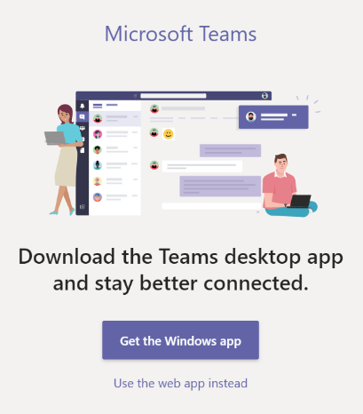
Note: the App Launcher gives you access to other Microsoft 365 apps that can help you with your studies at Birkbeck. These include OneDrive (personal file storage), OneNote (note-taking) and To-Do (task management).

If you are already signed into Teams on another account (e.g for work), go to your profile picture in the top right corner and sign out of that account, then sign back in again using your Birkbeck credentials.

Join live sessions in Teams

Before you join your live teaching session make sure you are logged in to the Teams app or Teams on the web (see above).

Click the Join live session link, either from your timetable in My Birkbeck, or module in Moodle.
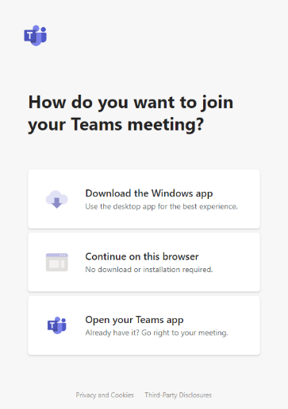

If you have the app click Open your Teams app. If you are using the web version, click Continue on this browser.

You will now see the audio/video settings screen. If you are prompted to enter your name here it means you are joining the session as a guest and are not logged in to Teams. Either close the window, log in to Teams then click the Join live session link again, or continue to the next screen (the lobby) and click sign in.

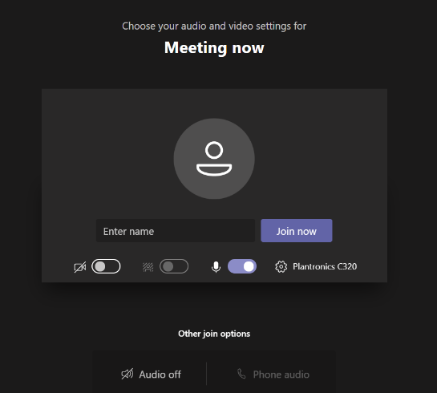

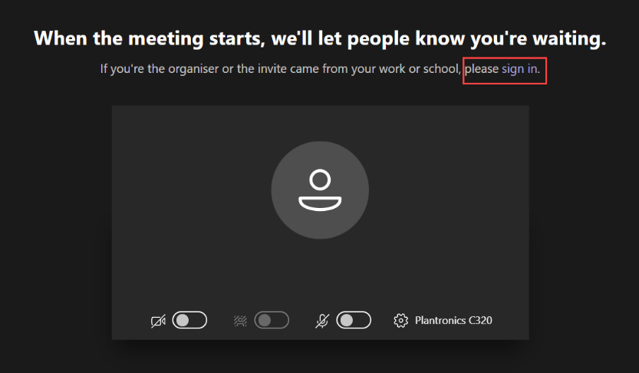

Once you are in the meeting you can check you are logged in to your Birkbeck account by clicking your profile picture. Your name is displayed with (Student) after it.

Need Help?
If you have difficulties with any of the above, please raise an Ask or contact the Service Desk on 020 3926 3456.

