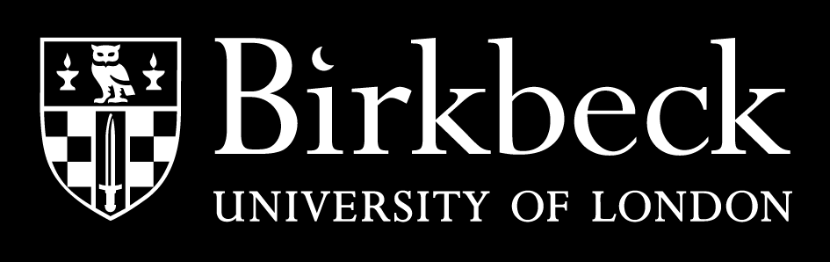
Alumni Scholarship

Application for an Award for 2019-20
Masters Degree
Please return your completed form by
26 July 2019

Personal Details | (IN BLOCK CAPITALS)
Surname or Family Name
Other Names in Full
Date of Birth | Date/Month/Year
Title
 | Male Female
Student number
Address

Email
Telephone
For which Masters Degree programme have you applied?

Have been accepted / conditionally accepted for the Masters Degree programme?

Personal statement (no more than 500 words). Please cover the following issues: 1. Why you applied to study at Birkbeck, 2. How will this opportunity support your career aspirations? 3. If you are working, how will you be able to apply your learning to your work?

Signature of Applicant
I confirm to the best of my knowledge that the details provided above are correct.
………………………..……………………………………… | Date  ………………………..

APPLICANTS: please return this form to:
Department of Economics, Mathematics and Statistics
Jo Kwok – Jo.Kwok@bbk.ac.uk

For official use only:
The Department is nominating the above applicant for the Sundstrom Scholarship for Postgraduate Taught Study

……………………………………………………………….. ………………….…….……….. …………………..
SIGNATURE OF HEAD OF GRADUATE COMMITTEE NAME DATE

